**Pizza Sales Queries**

1. **KPIs**
2. **Total Revenue**

SELECT CAST(SUM(total_price)AS DECIMAL(10,2)) AS Total_Revenue

FROM pizza_sales

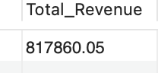

1. **Average Order Value**

SELECT CAST( SUM(total_price) / COUNT(DISTINCT order_id) AS DECIMAL(10,2)) AS Average_Order_Price

FROM pizza_sales

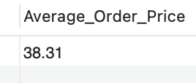

1. **Total Pizzas Sold**

SELECT SUM(quantity) AS Total_Pizzas_Sold

FROM pizza_sales

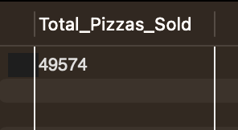

1. **Total Orders**

SELECT COUNT(DISTINCT order_id) AS Total_Orders

FROM pizza_sales

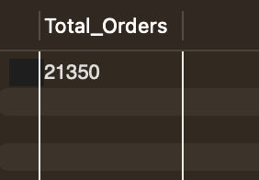

1. **AVG Pizzas Per Order**

SELECT CAST(SUM(quantity) / COUNT(DISTINCT order_id) AS DECIMAL(10,2 ))AS AVG_Pizzas_Per_Order

FROM pizza_sales

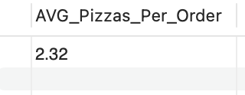

**B) Charts Requirements**

1. **Hourly Trend for Total Pizzas Sold**

SELECT

EXTRACT(HOUR FROM order_time) AS order_hour,

SUM(quantity) AS total_pizzas_sold

FROM

pizza_sales

GROUP BY

order_hour

ORDER BY

order_hour;

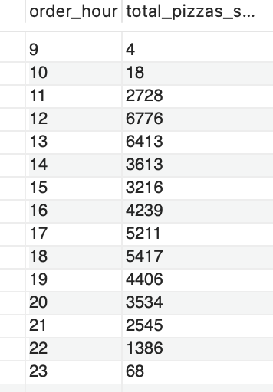

1. **Dailly Trend of Total Orders**

SELECT DAYNAME(STR_TO_DATE(order_date, '%Y-%m-%d')) AS Order_Day, COUNT(DISTINCT order_id) AS Total_Orders

FROM pizza_sales

GROUP BY DAYNAME(STR_TO_DATE(order_date, '%Y-%m-%d'))

ORDER BY total_Orders DESC;

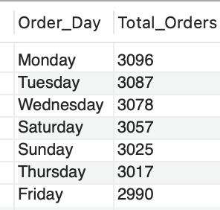

1. **Monthly Trends for Total Orders**

SELECT MONTHNAME(STR_TO_DATE(order_date, '%Y-%m-%d')) AS Order_Month, COUNT(DISTINCT order_id) AS Total_Orders

FROM pizza_sales

GROUP BY Order_Month

ORDER BY Total_Orders DESC;

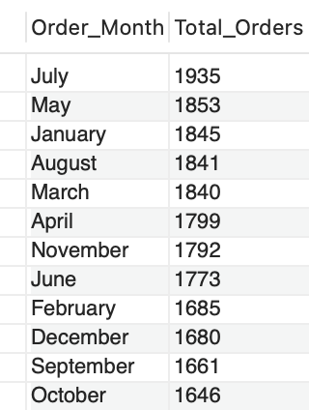

1. **Percentage of Sales by Pizza Category**

SELECT pizza_category,

CAST(SUM(total_price) AS DECIMAL(10,2)) AS Total_Sales,

CAST((SUM(total_price) * 100 / (SELECT SUM(total_price) FROM pizza_sales)) AS DECIMAL(10,2)) AS Sales_Percentage

FROM pizza_sales

GROUP BY pizza_category;

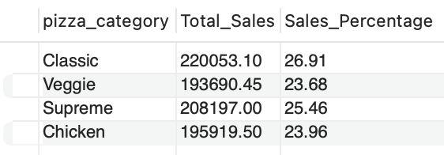

1. **Percentage of Sales By Pizza Size**

SELECT pizza_size,

CAST(SUM(total_price) AS DECIMAL(10,2)) AS Total_Sales,

CAST((SUM(total_price) * 100 / (SELECT SUM(total_price) FROM pizza_sales)) AS DECIMAL(10,2)) AS Sales_Percentage

FROM pizza_sales

GROUP BY pizza_size;

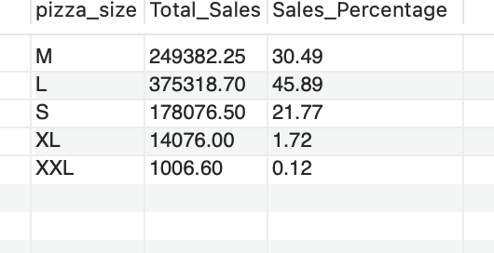

1. **Total Orders & Pizzas Sold By Category**

SELECT COUNT(DISTINCT order_id) AS Orders, SUM(quantity) AS Pizzas_sold, pizza_category

FROM pizza_sales

GROUP BY pizza_category

ORDER BY pizza_category

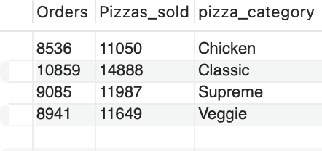

1. **Top 5 Pizzas By Revenue**

SELECT pizza_name_id AS Pizza_Name, CAST(SUM(total_price) AS DECIMAL(10,2))AS Pizza_Sales, SUM(quantity) AS Total_Quantity, COUNT( DISTINCT order_id) AS Total_Orders

FROM pizza_sales

GROUP BY pizza_name_id

ORDER BY SUM(total_price) DESC

LIMIT 5

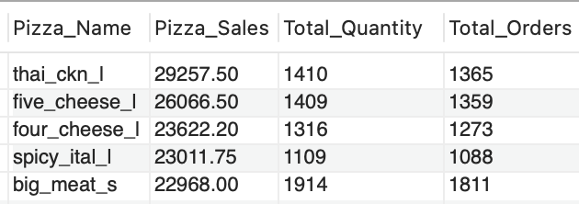

1. **Bottom 5 Pizzas By Revenue**

SELECT pizza_name_id AS Pizza_Name, CAST(SUM(total_price) AS DECIMAL(10,2))AS Pizza_Sales, SUM(quantity) AS Total_Quantity, COUNT( DISTINCT order_id) AS Total_Orders

FROM pizza_sales

GROUP BY pizza_name_id

ORDER BY SUM(total_price) ASC

LIMIT 5

